Principio del formulario
Hosts on two separate subnets cannot communicate. The network administrator suspects a missing route in one of the routing tables. Which three commands can be used to help troubleshoot Layer 3 connectivity issues? (Choose three.)
 | ping
 | show arp
 | traceroute
 | show ip route
 | show interface
 | show cdp neighbor detail

2 | Principio del formulario
  Why is it advisable to configure a next-hop IP address when creating a static route whose exit interface is an Ethernet network?
   | Adding the next-hop address eliminates the need for the router to do any lookups in the routing table before forwarding a packet.
   | In a multi-access network, the router cannot determine the next-hop MAC address for the Ethernet frame without a next-hop address.
   | A next-hop address provides a more specific route than an exit interface.
   | There is no advantage in including a next-hop address in the static route command.

3 | Principio del formulario
  What two devices are responsible for converting the data from the WAN service provider into a form acceptable by the router? (Choose two).
  the serial port of the router
  a modem
  a switch
  the ethernet port of the router
  a CSU/DSU device
  a DTE device
4 | Principio del formulario
  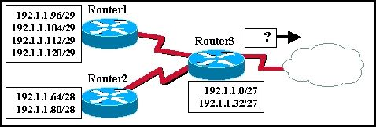
  The routers in the diagram use the subnet assignments shown. What is the most efficient route summary that can be configured on Router3 to advertise the internal networks to the cloud?
  192.1.1.0/26 and 192.1.1.64/27
  192.1.1.128/25
  192.1.1.0/23 and 192.1.1.64/23
  192.1.1.0/24
  192.1.1.0/25
  192.1.1.0/24 and 192.1.1.64/24

5 | Principio del formulario
  A static route that points to the next hop IP will have what administrative distance and metric in the routing table?
  administrative distance of 0 and metric of 0
  administrative distance of 0 and metric of 1
  administrative distance of 1 and metric of 0
  administrative distance of 1 and metric of 1
6 | Principio del formulario
  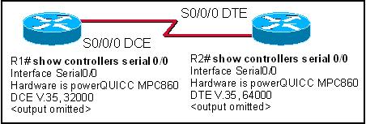
  Refer to the exhibit. Given the output in the exhibit, how would a clock rate be determined for this link?
  The rate would be negotiated by both routers.
  A rate would not be selected due to the DCE/DTE connection mismatch.
  The rate configured on the DTE determines the clock rate.
  The rate configured on the DCE determines the clock rate.

7 | Principio del formulario
  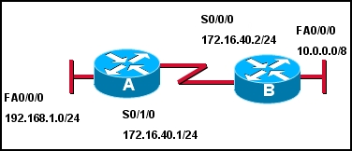
  Refer to the exhibit. What two commands are required to provide connectivity between the 192.168.1.0 and 10.0.0.0 networks without requiring recursive lookup? (Choose two.)
  A(config)# ip route 10.0.0.0 255.0.0.0 s 0/1/0
  A(config)# ip route 10.0.0.0 255.0.0.0 172.16.40.2
  A (config)# ip route 10.0.0.0 255.0.0.0 s 0/0/0
  B(config)# ip route 192.168.1.0 255.255.255.0 s 0/0/0
  B (config)# ip route 192.168.1.0 255.255.255.0 172.16.40.1
  B(config)# ip route 192.168.1.0 255.255.255.0 s 0/1/0
8 | Principio del formulario
  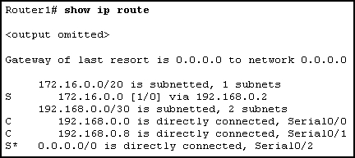
  Refer to the exhibit. How will packets destined to the 172.16.0.0 network be forwarded?
  Router1 will perform recursive lookup and packet will exit S0/0.
  Router1 will perform recursive lookup and packet will exit S0/1.
  There is no matching interface associated with network 172.16.0.0 so packets will be dropped.
  There is no matching interface associated with network 172.16.0.0 so packets will take gateway of last resort and exit out S0/2.

9 | Principio del formulario
  What address can be used to summarize networks 172.16.1.0/24, 172.16.2.0/24, 172.16.3.0/24, and 172.16.4.0/24?
  172.16.0.0/21
  172.16.1.0/22
  172.16.0.0 255.255.255.248
  172.16.0.0 255.255.252.0
10 | Principio del formulario
  Which of the following are displayed by the Router# show cdp neighbors command? (Choose three.)
  load
  platform
  reliability
  holdtime
  local interface

11 | Principio del formulario
  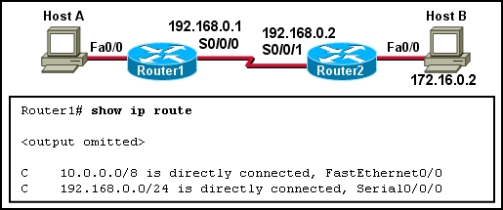
  Refer to the exhibit. Which static route should be configured on Router1 so that host A will be able to reach host B on the 172.16.0.0 network?
  ip route 192.168.0.0 172.16.0.0 255.255.0.0
  ip route 172.16.0.0 255.255.0.0 192.168.0.1
  ip route 172.16.0.0 255.255.0.0 S0/0/1
  ip route 172.16.0.0 255.255.0.0 S0/0/0
12 | Principio del formulario
  Which piece of information is available from examining the output of the command show ip interface brief?
  Interface speed and duplex
  Interface MTU
  Errors
  Interface MAC address
  Interface IP address

13 | Principio del formulario
  What happens to a static route entry in a routing table when the outgoing interface is not available?
  The route is removed from the table.
  The router polls neighbors for a replacement route.
  The route remains in the table because it was defined as static.
  The router redirects the static route to compensate for the loss of the next hop device.
14 | Principio del formulario
  Which statement is true concerning directly connected routes?
  They appear in the routing table as soon as cables are connected to the router.
  They appear in the routing table when an IP address is configured on an interface.
  They appear in the routing table when the no shut command is entered in the router interface configuration mode.
  They appear in the routing table when the show interface shows the interface is up, line protocol is up.

15 | Principio del formulario
  Which output represents a properly connected and configured router interface?
  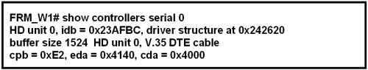
  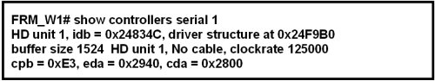
  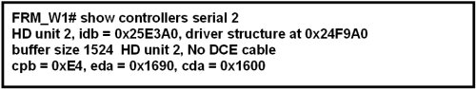
  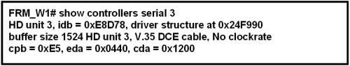
Principio del formulario
16. The output of the Router# show interfaces serial 0/1 command displays the following:
Serial0/1 is up, line protocol is down.
What is the most likely cause for the line protocol being down?
Serial0/1 is shutdown.
There is no cable connecting the routers.
The remote router is using serial 0/0.
No clock rate has been set.

17 | Principio del formulario
  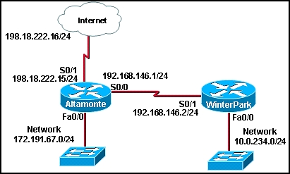
  Refer to the exhibit. Which set of commands will configure static routes that will allow the WinterPark and the Altamonte routers to deliver packets from each LAN and direct all other traffic to the Internet?
  WinterPark(config)# ip route 0.0.0.0 0.0.0.0 192.168.146.1
  Altamonte(config)# ip route 10.0.234.0 255.255.255.0 192.168.146.2
  Altamonte(config)# ip route 0.0.0.0 0.0.0.0 s0/1
  WinterPark(config)# ip route 0.0.0.0 0.0.0.0 192.168.146.1
  Altamonte(config)# ip route 10.0.234.0 255.255.255.0 192.168.146.2
  Altamonte(config)# ip route 198.18.222.0 255.255.255.255 s0/1
  WinterPark(config)# ip route 172.191.67.0 255.255.255.0 192.168.146.1
  WinterPark(config)# ip route 0.0.0.0 0.0.0.0 192.168.146.1
  Altamonte(config)# ip route 10.0.234.0 255.255.255.0 192.168.146.2
  WinterPark(config)# ip route 172.191.67.0 255.255.255.0 192.168.146.1
  Altamonte(config)# ip route 10.0.234.0 255.255.255.0 192.168.146.2
  Altamonte(config)# ip route 0.0.0.0 0.0.0.0 s0/0

18 | Principio del formulario
  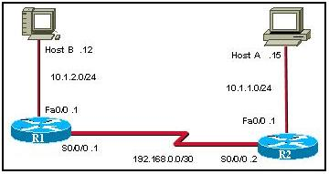
  Refer to the exhibit. Routers R1 and R2 have been configured with static routes to allow traffic between their respective Ethernet segments. A network technician issues an extended ping command from the console of R1 to the serial interface of R2 using a source address of 10.1.2.1. Will this be a valid test of the routes in R1?
  Yes. The echo reply has to come from R2 with a destination on the far side of R1 so the route must be present in R1.
  No. Both networks are connected to R1 so the echo reply from R2 will always succeed.
  Yes. Both R1 and R2 must have valid static or dynamic routes for the echo request and echo reply to succeed.
  No. It will be a valid test only of the routes in R2.

